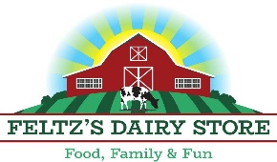

Feltz’s Dairy Store is looking for highly motivated and energetic employees, who can work in a fast-paced environment, with a positive attitude.
Potential positions and responsibilities include, but are not limited to, ice cream scooping, cashier, kitchen prep, cheese handling, stocking, and light cleaning.
Opportunity for tour guide position also available to those with a dairy background or education.
All positions will be part-time only.
Thank you for your interest in Feltz’s Dairy Store, we are happy to have you consider becoming a part of our team!

Application for Employment
Personal Information
Last Name First Name M.I.
Address City State Zip
Phone Email Address
Are you age 16 or older? [ ] Yes [ ] No
Are you a U.S. Citizen? [ ] Yes [ ] No
Have you ever been convicted of a felony? [ ] Yes [ ] No
If yes, please explain
Date available to begin work
Are you available to work evenings and weekends?
Education
 | School Name | Location | Highest grade/years completed | Did you graduate?
High School
College
College/Other

Other applicable training, certifications, or licenses held

Employment
Employer (current or most recent)
Dates Employed to Work Phone Pay rate $
Address City State Zip
Position
Duties Performed

Supervisor’s name and title
Reason for leaving
May we contact them? [ ] Yes [ ] No
References
Please provide two professional references
Name | Title | Company | Phone

Signature of Applicant Date

*Please submit completed application via email at feltzsdairystore@gmail.com, OR mail to 5796 Porter Dr. Stevens Point, WI 54482, OR deliver in person to store.

